Understanding the World

* Materials and their properties
* Ice experiments
* Baking Shortbread
* R.E – Special objects and places
* Drawing maps
* Creating video clips of children re-telling traditional stories

Mathematics

* Counting, recognising, forming and ordering numbers to 20
* Sharing groups of objects
* Naming 2D and 3D shapes and using mathematical terms to describe them
* Shape repeated patterns
* Measuring lengths and heights
* [http://www.tts-group.co.uk/_RMVirtual/Media/TTS/Images/SLSHAP_1_large.jpg](http://www.google.co.uk/url?sa=i&rct=j&q=&esrc=s&frm=1&source=images&cd=&cad=rja&uact=8&ved=0CAcQjRw&url=http://www.tts-group.co.uk/shops/tts/Range/3D-shapes/768d9dfd-2ae8-4277-9059-bb74a9bbd848?pagesize%3D-1&ei=aY6-VJ1qx65T1eCAwAo&bvm=bv.83829542,d.d2s&psig=AFQjCNHe6zkZQg3Kd8Ga4Tj3uIoh3YGuCA&ust=1421860829371380)Time- ‘o’ clock

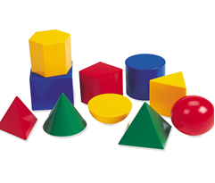

Communication and Language

Literacy

* Set 1 sounds (Read, Write, Inc)
* Capital letters / letter names
* Reading words and sentences with increased confidence
* Independently re-telling traditional stories, showing an awareness of the listener.
* Acting out familiar stories with friends, taking on differing roles
* Writing captions and short sentences using their phonic knowledge.

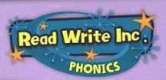

Physical Development

* Ball skills
* Using the climbing equipment and creating obstacle courses
* Finger Gym- Fine Motor Skills
* Learning about the importance of exercise, a healthy diet, sleep and good hygiene.
* Safety routines

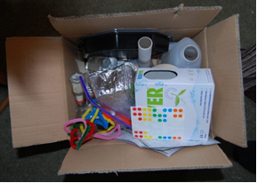

Expressive Arts and Design

* Using clay, play dough and junk modelling to design and make houses
* Making masks of characters to act out traditional stories
* Materials collage
* Printing
* Cutting and Sticking
* Observational drawing and painting
* Music
* Singing and dancing

Traditional Tales

Personal, Social and Emotional Development

* Showing sensitivity to the needs of others
* Conflict resolution
* Taking turns and sharing
* Developing independence
* Talking about we are good at and what we’d like to get better at (target setting)

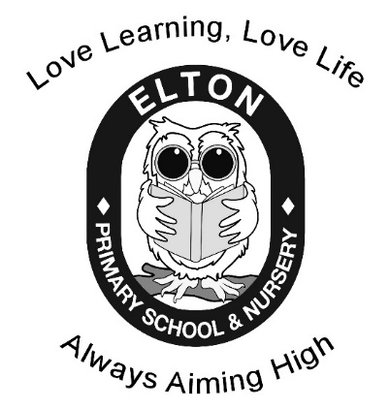

**Oh the Place you will go!**

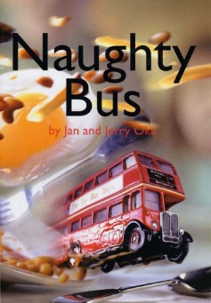

**Reception Spring Learning Leaflet**

Mrs. McCarroll Miss Lofthouse

Ways to help at home-

Read as much as you can- from stories (particularly traditional ones), to magazines, to menus in restaurants! Encourage the children to read to you at night and get them to use the pictures as prompts. Ask ‘why’ and ‘how’ questions to extend their thinking. Ask them what letters they recognise and encourage them to ‘Fred talk’. Don’t forget to sign and write a short comment in their reading diary so that we know they have read.

Talk as much as you can! Question why things happen and how things work. Have discussions about all things big and small- from ‘what do you fancy for tea?’ to ‘why do you think fish can’t live on land?’ Share feelings, thoughts and opinions.

Provide lots of opportunities to work on number. Count often and in informal contexts i.e. count as you walk up the stairs or counting fruit in the bowl etc. Pose practical problems i.e. how many plates will we need out for dinner? Can you please share those sweets out equally between you brother? Etc.

Encourage independence when possible. I have two children and often find myself doing things I know they are capable of! I know our time is sometimes limited but please encourage your children to be as independent as possible i.e. getting dressed in the morning, putting their shoes on, helping to do jobs around the house or helping to make dinner.

Please don’t forget to send a water bottle in with your child. These can be topped up throughout the week, as we place a great deal of importance on children having continual access to drinking water.

Wow, we can’t believe how quickly the first term went- it seems like only yesterday the children started school for the first time! They have all become so confident and independent and all seem genuinely excited to learn.

The whole EYFS team are very excited about the new term. The topic is “Oh the Place you will go” and we will be reading stories such as-

* The Train ride
* Naughty Bus
* On the Road
* Tell me a Dragon
* And many more…

These stories provide starting points for a wealth of exciting learning opportunities and we aim to make these activities as practical as possible- making a bus and role playing, sharing experiences of travelling, folding paper aeroplanes, creating a map of home to school Journey and using remote controlled vehicles etc.

**If you ever have any questions about what we do here at school please feel free to ask, as we believe that when home and school work closely great things can be achieved.**

**The EYFS team x**