Vocabulary | Definition
climate | average measurements of temperature, wind, humidity, snow, and rain in a place over the course of years.
capital city | as the location of the government's central meeting place and offices
country | a nation with its own government, occupying a particular territory.
landscapes | The landscape is everything you can see when you look across an area of land, including hills, rivers, buildings, trees, and plants.
weather | the state of the atmosphere with respect to heat or cold, wetness or dryness, calm or storm, clearness or cloudiness
river mouth | The end of a river where it flows into the sea, another river or a lake.
estuary | An estuary is an area of freshwater that meets the ocean
river source | the furthest point on the river from its mouth
Rhine | one of the major European rivers, which has its sources in Switzerland and flows in a mostly northerly direction through Germany and the Netherlands, emptying into the North Sea
Eastern and Central Europe – Year 4 – Geography – Summer 2
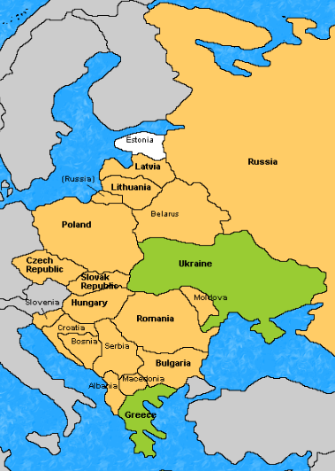
Eastern European countries

Central European countries | Capital city
Austria | Vienna
Switzerland | Geneva
Liechtenstein | Vaduz
Germany | Berlin
Poland | Warsaw
Czech Republic | Prague
Slovakia | Bratislava
Hungary | Budapest
Slovenia | Ljubljana

Eastern European Countries | Capital city
Belarus | Minsk
Bulgaria | Sofia
Czechia | Nicosia
Hungary | Budapest
Moldova | Chisinau
Poland | Warsaw
Romania | Bucharest
Russia | Moscow
Slovakia | Bratislava
Ukraine | Kiev
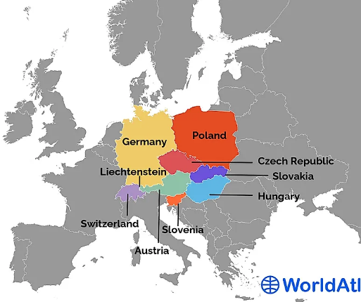
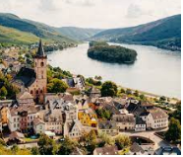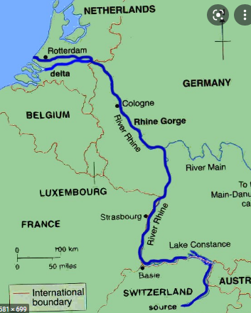
River Rhine
Central European countries

