Focus: DT | Food Technology  Fruit Salad | Year 4 | Summer 2
Key Vocabulary

Purpose
User
Nutrition/nutrients
Balanced
Diet
Hygiene
Seasonality
Chopping
Bridge hold
Claw grip
Recipe
Flavour
Texture
Appearance/presentation

Key Knowledge

Design-make-evaluate process

Understand the need for an intended user and purpose
Develop understanding of balanced diet – links between health and nutrition (Eatwell plate)
Understand that cooking is an important life skill – what would happen if we didn’t learn to cook?
Continue to follow the rules for cooking safely and hygienically.
Explore the idea of seasonality.
Choose the correct equipment to create the fruit salad.
Write a recipe.
Use the correct techniques for the task – claw grip/bridge hold -confidently
Explain what they like about their dish and how they could improve it.

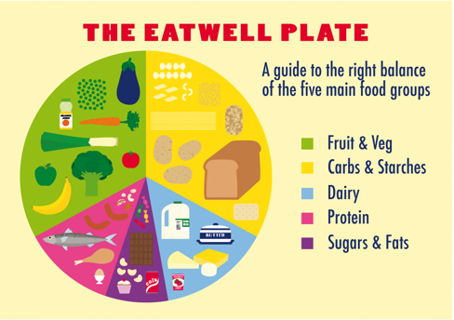

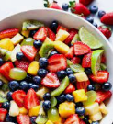
Possible Experiences
- Food tasting of possible fruit salad ingredients from exotic countries
- Outside agencies or parents with a background in cooking to visit
- Research background of fruit salad
- Visit to a supermarket
- Create and name a new salad using seasonal fruits

