Volcanoes and Earthquakes– Year 4 Knowledge Organiser

|  |  |
| --- | --- |
| Key vocabulary | |
| **volcano** | An opening in the Earth's crust from which lava, ash, and hot gases flow or are ejected during an eruption. |
| **magma** | Hot fluid or semi-fluid material below or within the earth's crust from which lava and other igneous rock is formed on cooling |
| **lava** | Lava is a liquid, that cools into rock, which is a solid |
| **crater** | A volcanic crater is a roughly circular depression in the ground caused by volcanic activity. It is typically a bowl-shaped feature within which occurs a vent or vents |
| **Earth’s crust** | A thin shell on the outside of the Earth. |
| **eruption** | When magma is released from a volcano. |
| **earthquake** | A sudden violent shaking of the ground, typically causing great destruction, as a result of movements within the earth's crust or volcanic action. |
| **plate tectonics** | Earth's outer layer is made up of large, moving pieces called plates. All of Earth's land and water sit on these plates. The plates are made of solid rock. |
| **epicentre** | Part of the earth's surface directly above the focus of an earthquake |

|  |  |  |
| --- | --- | --- |
| Key Facts | |  |
| **Volcanoes** | Volcanoes are made when pressure builds up inside the earth. This affects the earth’s crust causing magma to sometimes erupt through it.  **Active** volcanoes have erupted in the last  10,000 years.  **Dormant** volcanoes haven’t erupted in the last 10,000 years but may erupt again.  **Extinct** volcanoes aren’t expected to erupt again. |  |
| **Earthquakes** | • Earthquakes are caused when the earth’s tectonic plates suddenly move.  • Most earthquakes occur near the tectonic plate boundaries.  • Earthquakes can cause lots of damage to roads, buildings and property.  • The power of an earthquake is measured using the Richter Scale. |  |
| **Tectonic plates** | Most tectonic activity is along plate margins and the edge of continents. Some volcanoes form over hot spots in the mantle. The **Ring of Fire** is a region around much of the rim of the Pacific Ocean where many volcanic eruptions and earthquakes occur. |  |

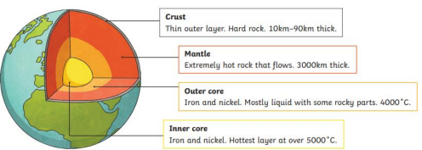

**Some of the world’s most famous volcanoes**

* Mount Vesuvius, near Naples, Italy •
* Eyjafjallajökull, Iceland

**What I should already know**

* I live in Elton, which is a town in Cheshire.
* The country I live in is called England.
* England, which is in the United Kingdom, is in the continent of Europe.
* There are seven continents and five oceans.

**Layers of the Earth**