Year 4 – Romans – Knowledge Organiser

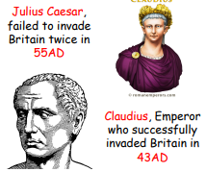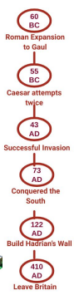**The Roman Empire and its impact on Britain**

**The Roman Army conquering Britain**

7. A hundred years later, In 41 AD, the new emperor of Rome, **Claudius**, decided to invade Britain again

8. He came to Britain with 40,000 soldiers, war machines and elephants.

9. He conquered most of Britain. People and their land now belonged to Rome and this is how we became a part of the Roman Empire.

10. Life in Britain became more like life in Rome. The Romans build towns and roads, which still exist today.

|  |  |
| --- | --- |
| **Vocabulary** | **Meaning** |
| celts | People living in Britain and some parts of Europe after the Iron Age. |
| emperor | Leader, ruler or king of an empire |
| empire | Many countries that are ruled by one leader |
| settlement | A place where people decide to live |
| invasion | When a foreign army enters a country by force |
| Julius Caesar | A famous Roman leader |
| Claudius | A great Roman emperor |
| Hadrian’s wall | Hadrian's Wall was a barrier that the Roman Empire built to keep invaders from the north out of the Roman province of Britain. |

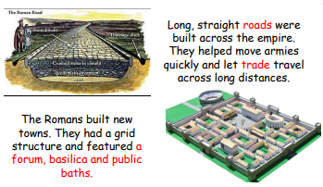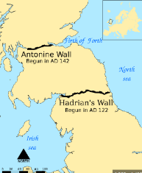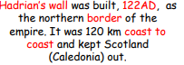

**Britain and the first invasions by the Roman Army**

1. We now call the people that lived in Britain between 750BC and 12BC **Celts.** They lived in settlements like hill forts. They were ruled by chiefs.
2. The romans had a huge, organised army that included very skilled soldiers.
3. In 55BC and 54BC, the general of Rome called **Julius Caesar,** tried to invade Britain.
4. He bought his organised army that had 25,000 men and 800 ships.
5. **Julius Caesar** invaded Britain twice but didn’t manage to take over the land.
6. The Romans invaded Britain to **conquer land, gain more slaves and collect the many precious resources** in Britain including metal such as **lead, tin, gold and silver.** Unfortunately, they wanted more power.