Term: Summer 2 Topic: The Next Adventure Year Group: Reception
 | English | Maths | Wider Curriculum
 | Supertato | Find my pattern, | Super Space
Book links | 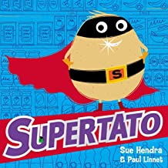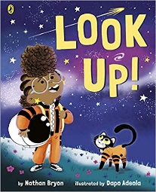 | 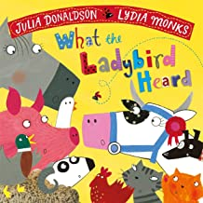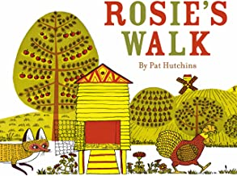 | 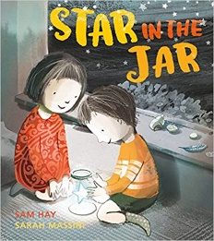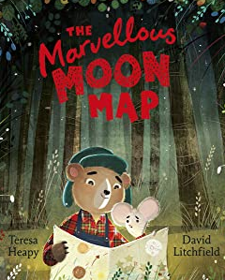
Specific Vocabulary | Superhero  Villain  Rescue  Protect  Super power  Universe  Intergalactic | Subitising  Doubling  matching pairs  Sharing  Grouping  Odd  even  Half  Equal groups | Space  Star  Marvellous  astronaut
Sticky Knowledge about… | A sentence needs:  Capital letter to start  Finger space between words  Full stop at the end.  I know the sounds:  ay, ee, igh, oo, ow, oo, ar, air, or, ou, ir, oy  I know the tricky words:  I, to, the, go, no, said, my, you, your | I know quantity of a group can be changed by adding more.  Halving something is when things are split into two equal groups.  Doubling something is when you have 2 of the same amount.  An even number is a number that can be divided into two equal groups. An odd number is a number that cannot be divided into two equal groups. | In space you float.  People that go to space are called astronauts.  A map is a drawing of part of Earth's surface.  Maps are used to show where things are.  You need a rocket to take you into space.

