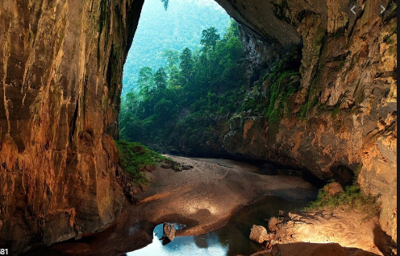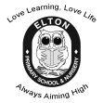

**Year 4 Learning Leaflet**

**Summer 2022**

**Planet Earth**

Forests or caves – where would you like the live?

Love Learning, Love Life

Always Aiming High

**Hello and welcome back to our final term in Year Four,**

We hope that you enjoyed the Easter break and are well rested and ready to work hard, for the last term as year four! We have lots of exciting things planned for this half term and we are certainly excited to see what you can do. Our main topic this term is Planet Earth which will be looked at within English, Art and DT. For your final term, there will be a huge emphasis on handwriting, making sure you are able to use a clear and neat cursive script ready for year five.

**PE**

PE will be on a Tuesday and Friday. This term we will be focusing on athletes, cricket, rounders and tag rugby. You need to have a labelled PE kit in school at all times. It can be taken home to be washed half-termly.

**Homework, Spellings and Reading**

You should be continuing to practise all times tables at home (up to 12 x 12), ensuring you have quick recall ready for the times table test in June. Spelling sheets will be given out at the beginning of each half term, these should be practised at home and will be practised in school. Maths Homework and Learning Log will be given out on a Friday to be returned every Wednesday. Reading books need to be changed at least once a week and don’t forget to bring your Reading Journal and book in every Tuesday and Thursday so that we can keep up to date with all of your fabulous reading at home.

**Miss Preugschat and Mrs Wilson**



In **R.E** we will continue learning about Humanism and Hinduism. Within these units, we will be able to describe and make connections between different features of the religions and worldviews we have studied. We will discuss celebrations, worship, pilgrimages and rituals which mark important points in life and reflect on ideas.

In **Science** this term, we will be focusing on Electricity and Big Build. We will link this to our topic of ‘Planet Earth’. We will be carrying out investigations and exploring new ideas.

In **French**, our topic is based on the hungry giant. This will include describing fruits and vegetables and finding how to ask politely for these items. We will continue to develop our skills in conversational French and learn about French culture.

In **DT** we will learn about different fruits from the forest and we will create our own fruit salad.

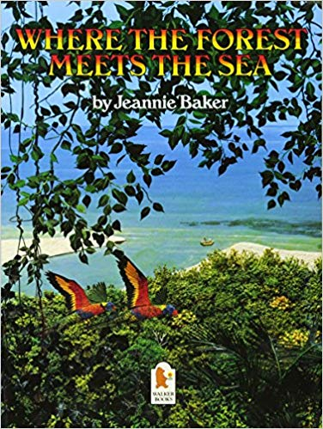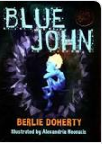

In **Music** our topic is called the Blackbird. All the learning in this unit is focused around one song: Blackbird by The Beatles - a song about civil rights.

In **Computing** we will be looking at emailing within our unit programming. This will include learning about algorithms, debugging and repeats and loops.

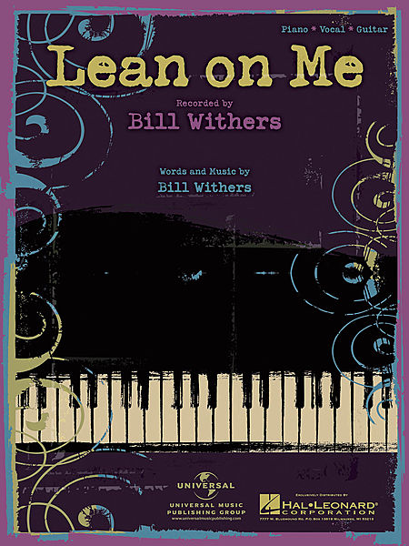

In **English** we will be using the books: Where the Forest Meets the Sea and Blue John. This term we will continue to focus on ambitious vocabulary, fronted adverbials, dramatic openers and using a variety of interesting punctuation. We will be writing in a variety of ways, looking to refine our skills for both fiction and non-fiction. Within our thematic approach to learning there will be lots of exciting speaking and listening opportunities from role play to debates.

In **Maths** we will be embracing the new National Curriculum, looking at:

* Geometry: Properties of Shape
* Geometry: Position and Direction
* Decimals
* Area
* Measurement: Money and Time.

In **P.E** we will be covering athletics, tag rugby, cricket and rounders. We will be developing skills in all sports and playing games. This term we are hoping Sports Day can go ahead so we can develop our competitive sportsmanship and sharing our sporting talents.



Our **Geography** this term will involve us learning about forests of Europe and rainforests found in South America. We will look closely at Europe and discover how it is mainly a forest environmental region.