Location
Ancient Greece
Modern day Greece
Year 4 – Ancient Greece – Knowledge Organiser
Vocabulary | Definition
Athens | a city-state that focused culture
Sparta | a city-state that focused on war
Acropolis | an ancient citadel (fortress) usually on a hill
city-states | small states in Ancient Greece
democracy | a form of government where citizens have a say how they are ruled
Olympics | an athletic event held every 4 years
oligarchy | a small group of people having control of a country.
law | the set of rules that people in society must follow
settlements | any small community of people
colonies | a group of people from one country who build a settlement on another land
seafarer | being someone who is employed to serve aboard any type of marine vessel

Ancient Greece
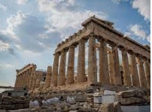
776 BC - 146 BC

Athens V Sparta
The two city-states that best represent each form of government were Sparta (oligarchy) and Athens (democracy). Athens focused more on culture, while Sparta focused more on war. The oligarchy structure in Sparta enabled it to keep war as a top priority.
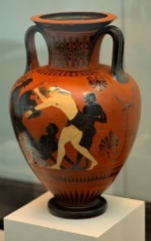
Olympic Pottery
Some of the evidence about the Olympic Games comes from paintings, most commonly found on vases!

Things to know
We know that Ancient Greece had a huge impact on the Western World. This includes:
- Founding the first proper democracy.
- The Olympics actually started in Ancient Greece. The different city states often fought but during the Olympics, peace was declared and everyone came together to enjoy the games.
- Mathematical and scientific discoveries which are still important today.
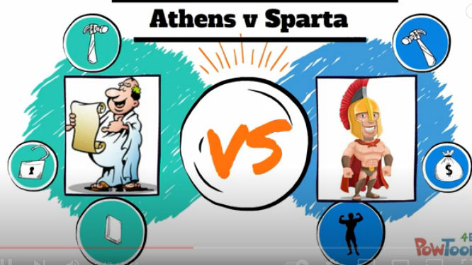
Importance of location of Ancient Greece
Mainland Greece is a mountainous land almost completely surrounded by the Mediterranean Sea. The ancient Greeks were a seafaring people. They traded with other countries around the Mediterranean. Many cities created settlements overseas known as colonies. The ancient Greeks mostly settled on the coast near the seas.

