RE Focus: | HOW DO HINDUS WORSHIP? | Year  4

Key Knowledge
How do Hindus show their faith? | God exists in everything so it is important to respect all living things (vegetarians).  Life is a cycle of birth, death and rebirth.  Every action we make has an effect or consequence called Karma.  Deity means god, Hindus believe in one god that can take the form of many different deities  Worship of God helps to lighten the mind – light removes darkness.
A Hindu life: what is important? | 4 key concepts Kama, Dharma, Moksha, Artha.  Life is like a journey.  You must follow your aims and duties to stay on your life’s path and follow the journey.
What is it like to be a Hindu in Britain today? | Indian food is a good way to show how well Indian cultures have fitted into British life.  Diwali is celebrated heavily in England.  Create a happy and safe country in which everyone can achieve their potential, whatever religion or background we come from.

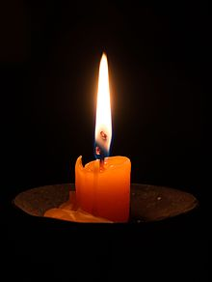
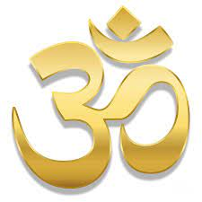
Key Vocabulary

Aum (or Om) | sacred sound and spiritual symbol, representing the Ultimate Reality.
Reincarnation  Samsara | the rebirth of a soul in another body.  The cycle on reincarnation
Murtis | Special statues or images of Hindu gods and goddesses.
Monotheism | belief in one God
Polytheism | belief in many Gods
Puja | worship ritual.
Moksha | ultimate liberation from the cycle of birth and death, and reunion with God
Holi | is the ‘festival of colours’ and marks the beginning of spring with bonfires and lots of singing and dancing.
Samskars | various stages (ceremonies) in life are marked by rites of passage

