Year 4 – Northern Europe – Focusing on similarities between North West and Bay of Naples
Vocabulary | Definition
region | a specific region that has common features
diverse | means differences
Ordnance Survey map | an organisation that creates maps of Great Britain
symbols | small pictures that stand for different features on a map
North West of England | a region in the North West of England
landscape | an area of land as one can see it
land use | human use of land
settlement | places where people live and sometimes work
Bay of Naples | a bay located on the South-Western coast in Italy
volcano | a mountain or a hill with an opening

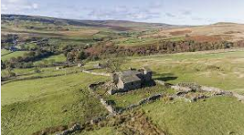
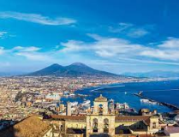

Bay of Naples
North West of England
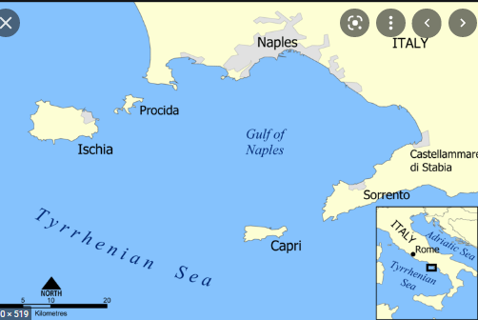
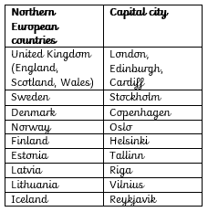
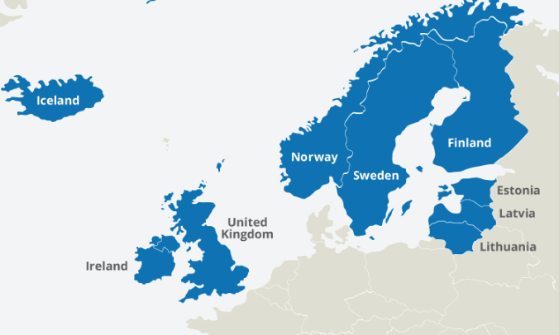
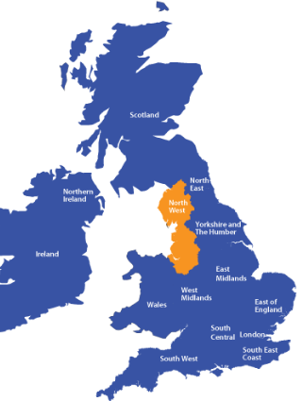
Northern European countries
Things to know
North West of England
The North west is a wide area and contains a variety of land use (e.g. built up residential and business areas as well as farmland, woodland and coastal areas different sized settlements from villages to cities such as Manchester and Liverpool. There are areas, which are flat, but also hilly, mountainous areas, such as the Pennines and Lake District. Manchester and Liverpool city areas are generally flat, as is the North-west coastline.

Ordnance Survey Maps
In the U.K. we have a unique geographical source - Ordnance Survey maps which show physical and human features but so much more than most maps and satellite images such as contours, heights, scale, place names etc.
Bay of Naples – South-Western coast of Italy
The Naples Bay region is dominated by the coast and Mount Vesuvius (volcano) and the human features are influenced by these.

What is a volcano?
The opening in the earth’s crust where lava and gas break out to cause devastation on the surrounding land, but there are positives as well as negatives of living near a volcano!

