Henri Rousseau, Impressionist Painting– Year 4 Knowledge Organiser
Impressionism was a form of French Art between 1886 and 1905
Key Vocabulary

Sketch – to draw lightly, start with ghost lines
Observation – to look carefully
Mark making – different lines, patterns and textures which can add depth/ texture to a sketch
Line - straight or curved pencil marks joining 2 points together
Tone - light and dark shades of a colour
Texture – the feel/ appearance of a surface
2D- two dimensional is flat-has length and width
3D - three dimensional looks solid – has length, width and height

Famous Paintings
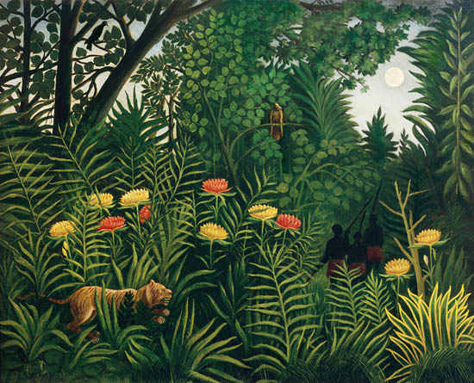
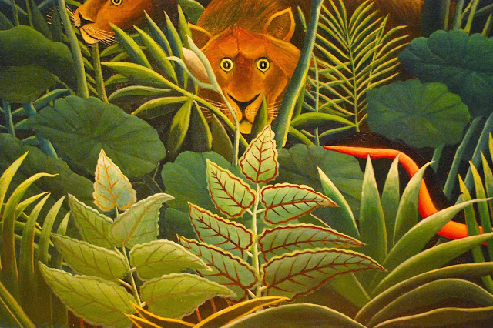
Henri Rousseau
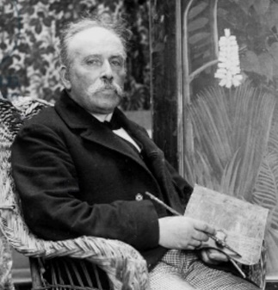
Skills for Y4 Jungle landscape painting
- darken colours using black
- use colour on a large scale
- use a range of materials to create jungle scene creating figures and shapes

Born in France in 1844
Died in 1910
Best known for painting jungle scenes
An exhibition of his work was in the Tate Modern

