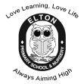

Love Learning, Love Life

Always Aiming High

**Hello and welcome back after the Christmas Holidays.**

We hope you enjoyed the break and are well rested and ready to work hard! We have lots to learn this term and we have been busy planning lots of exciting learning opportunities and lessons for you.

Our main topic this term is Disasters. We will research the changes in Britain through the Romans. In Literacy, we will be reading the story Escape from Pompeii, and we have lots of new skills to learn!

There will be a huge focus upon handwriting and presentation this half term; everybody must be joining their writing and thinking about how to present work to a high standard. Everyone must also be joining their letters in the correct way. Please let us know if you would like handwriting sheets to practise at home.

Skills to keep up at home - It is also really important to continue to read at home regularly to improve comprehension skills and fluency. We ask that you read at least twice a week with your adults, and lots on your own! Please make sure that your Reading Record is written in so that we can see when you have been reading.

**There will be a continued huge push on learning your times tables this year; at the end of Year 4 you should be able to recall up to 12 x 12. We will continue to use Times Tables Rockstars in class and at home to improve your recall.**

Keep accessing Bug Club and Times Table Rock Stars. If you need new Bug Club books then please let one of us know!

Remember to have your PE kits in school every day please! Our PE day continues to be Tuesday afternoon, so make sure you have your kits ready for the first week back in school.

**Miss Preugschat and Mrs Deakin**

**Disasters!**





In **French** we will be given the fantastic opportunity of working with a French specialist. We will develop our skills in conversational French and learn about the French culture.

In **R.E** we will be learning about Christianity. During Autumn term one we will look at Christian parables; understanding Jesus’ teachings about God. We will then delve into the Christian and Jewish beliefs about the creation of the world.

In **Computing** we will be looking at the importance of staying safe online, where we will discuss and advise each other of the dangers and what can be done to keep us safe. We will then start an exciting unit of work on coding; learning what an algorithm is and how to use these to create games and other exciting things.

**Year 4 Learning Leaflet**

**Spring 2019**

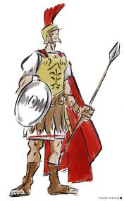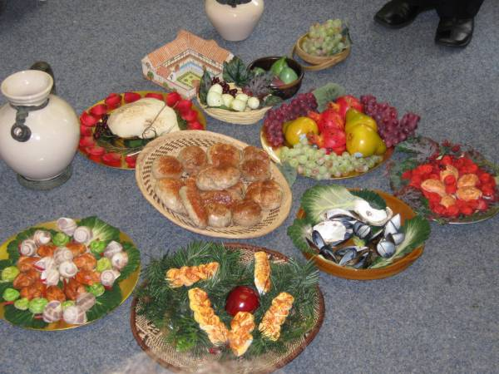

Our topic will focus on Disasters

In **R.E.** we will be learning about the Sikh religion. We will learn about Sikh beliefs and practises, including belief in One God. We will then go on to study how Sikhs worship, including The Gurdwara. Finally we will find out about Sikh celebrations, including ceremonies, marriages and Holy Days.

In **Science** this term, we will be focusing on States of Matter. We will learn about solids, liquids and gases, and will discuss how we measure temperature. We will also learn about the Water Cycle.

Our **Topic** this term will be taught through a creative topic approach, where we will look at the impact on Britain through the invasion of the Romans. We will learn about the Roman Empire, Hadrian’s Wall, Britain’s resistance to invasion, including Boudicca, and the ‘Romanisation’ of Britain, particularly looking at local impact in Chester.

In **Music** this is a six-week unit of work that continues to teach about the language of music through playing the glockenspiel. The learning is focused around exploring and developing playing skills through the glockenspiel.

In **Art** we will learn about Roman Mosaics. We will plan and design our own Roman Mosaic tile.

In **DT** we will design and create our own Roman sandals.

In **French** we will continue to work on the topic ‘All about me’ and begin to learn counting, days and months of the year – so we can say our birthdays in French.



In **Maths** our soul focus for the first half term will be Multiplication and Division, learning our times tables and the relationship between multiplication and division facts. We will also learn to do multiply 3 numbers together and to multiply 3 digits by 1 digit using a variety of methods.

We will then move on to measure, looking at units of measure including area. Finally, before Easter, we will begin our units on fractions and decimals.

In **P.E** this term we will be focusing on improving our health and fitness through a variety of sports. We will participate in gymnastics, where we will cover a range of balances and movements and practise simple routines. We will also cover a variety of games which improve our ball control skills, including netball/basketball and football.

In **English** we will be reading ‘Escape from Pompeii’. We will cover reading comprehensions, synonyms and antonyms, thesaurus work and different types of words. We will also look at different types of adjectives (simple, comparative and superlative) and the spelling rules linked to these. We will write character descriptions, take part in drama to do with the story, and revisit our learning about how to write and punctuate direct speech.

As we become more familiar with the text, we will then go on to write our own alternative version of the story, changing certain key details. We will also revisit persuasive writing to write a letter persuading the people of Pompeii to either stay or leave.

In **Computing** we will be looking at using technology which allows us to communicate, including email. We will also be looking at E-Safety in regards to communicating online.