Year 4 – Southern and Eastern Europe – Knowledge Organiser
Vocabulary | Definition
Mediterranean | From the latin word meaning ‘middle of the land’
Europe | A continent located between asia and the Atlantic Ocean
country | A nation with its own government
continent | A large solid area of land
capital city | A city in a country where the government functions
climate zone | An area that has its own distinct climate
environmental regions | A specific area that has common features
tundra | A large, barren region with no trees
mountainous | A region that has many mountains
topographical features | The shape of physical features on a surface

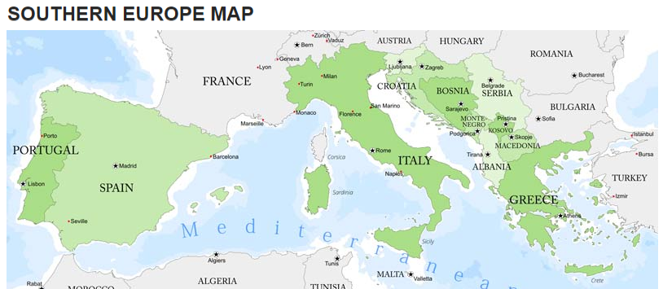

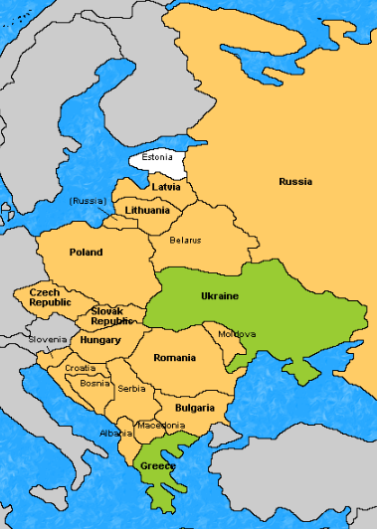
Eastern Europe

Country | Capital city
Belarus | Minsk
Bulgaria | Sofia
Czechia | Nicosia
Hungary | Budapest
Moldova | Chisinau
Poland | Warsaw
Romania | Bucharest
Russia | Moscow
Slovakia | Bratislava
Ukraine | Kiev
Things to know
Eastern Europe is the eastern part of the European continent.
• Eastern Europe is dominated by Russia and the countries formerly a part of the Soviet Union.
• Eastern Europe is surrounded by four seas – Caspian Sea, Black Sea, Adriatic Sea and Baltic Sea

Climate
Eastern Europe is classified as having a Continental climate, which features warm to hot summers and cold winters.

Things to know

Climate
Southern Europe has a Mediterranean climate, which features warm to hot, dry summers and cool to mild winters and frequent sunny skies.
Country | Capital city
Italy | Rome
Spain | Madrid
Portugal | Lisbon
Greece | Athens
Turkey | Ankara
Malta | Valletta

