Wow, we cannot believe how quickly this year is going - it seems like only yesterday the children started school for the first time! They have all become so confident and independent and all seem genuinely excited to learn.

The whole reception team are very excited about the new term. The topic is ‘The Next Adventure’ and we will be reading stories such as-
- Supertato
- Look up
- The Marvellous Moon Map
- And many more…
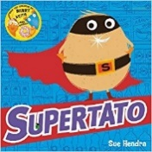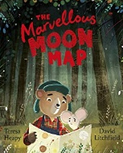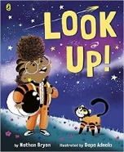
These stories provide starting points for a wealth of exciting learning opportunities and we aim to make these activities as practical as possible- decorating Supertatoes, making masks and role playing, constructing secret lairs out of boxes etc.
If you ever have any questions about what we do here at school please feel free to ask, as we believe that when home and schoolwork closely great things can be achieved.
The reception team x

Ways to help at home-

Read as much as you can- from stories (particularly traditional ones), to magazines, to menus in restaurants! Encourage the children to read to you at night and get them to use the pictures as prompts. Ask ‘why’ and ‘how’ questions to extend their thinking. Ask them what letters they recognise and encourage them to ‘Fred talk’. Do not forget to sign and write a short comment in their reading diary so that we know they have read.

Talk as much as you can! Question why things happen and how things work. Have discussions about all things big and small- from ‘what do you fancy for tea?’ to ‘why do you think fish can’t live on land?’ Share feelings, thoughts and opinions.
Provide many opportunities to work on number. Count often and in informal contexts i.e. count as you walk up the stairs or counting fruit in the bowl etc. Pose practical problems i.e. how many plates will we need out for dinner? Can you please share those sweets out equally between you brother? Etc.

Encourage independence when possible. I have two young children and often find myself doing things I know they are capable of! I know our time is sometimes limited but please encourage your children to be as independent as possible i.e. getting dressed in the morning, putting their shoes on, helping to do jobs around the house or helping to make dinner.

Please do not forget to send a water bottle in with your child as we place a great deal of importance on children having continual access to drinking water.

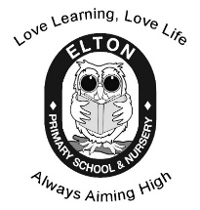

Reception Summer
Learning Leaflet

Mrs. McCarroll and Miss Lofthouse

Term: Summer 2 Topic: The Next Adventure Year Group: Reception
 | English | Maths | Wider Curriculum
 | Supertato | Find my pattern, | Super Space
Book links | 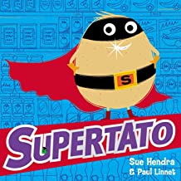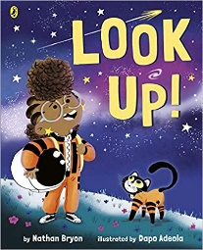 | 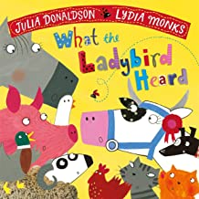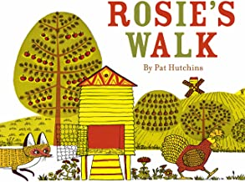 | 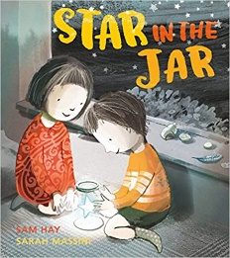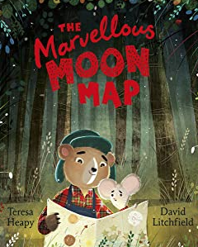
Specific Vocabulary | Superhero  Villain  Rescue  Protect  Super power  Universe  Intergalactic | Subitising  Doubling  matching pairs  Sharing  Grouping  Odd  even  Half  Equal groups | Space  Star  Marvellous  astronaut
Sticky Knowledge about… | A sentence needs:  Capital letter to start  Finger space between words  Full stop at the end.  I know the sounds:  ay, ee, igh, oo, ow, oo, ar, air, or, ou, ir, oy  I know the tricky words:  I, to, the, go, no, said, my, you, your | I know quantity of a group can be changed by adding more.  Halving something is when things are split into two equal groups.  Doubling something is when you have 2 of the same amount.  An even number is a number that can be divided into two equal groups. An odd number is a number that cannot be divided into two equal groups. | In space you float.  People that go to space are called astronauts.  A map is a drawing of part of Earth's surface.  Maps are used to show where things are.  You need a rocket to take you into space.

