Zentangle– Year 4 Knowledge Organiser – Spring 2
The Zentangle Method is an easy-to-learn, relaxing, and fun way to create beautiful images by drawing structured patterns.
There are lots of ‘pre-designed’ Zentangles we can borrow...
Key Vocabulary

Tangle – the repeated patterns, which vary in difficulty, that make up a zentangle
Template - a shape which is used to draw around or from, to use as a starting point
Zentangle – an image created by drawing structured patterns, often used as a form of relaxation
Elemental Strokes - S-curves and orbs you create
Tiles - patterns are drawn on small pieces of paper
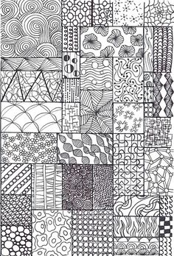
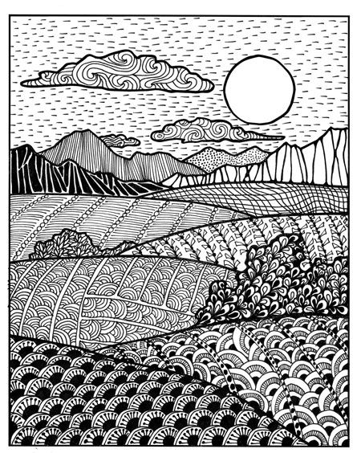
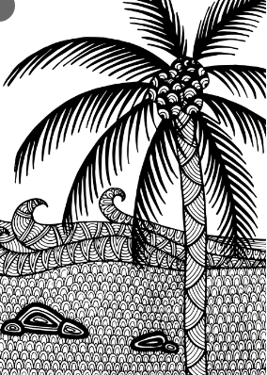
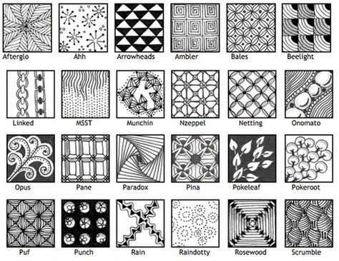
Skills for Year 4 Zentangle
- Zentangle art is non-representational and unplanned so you can focus on each stroke and not worry about the result.
- There is no up or down to Zentangle art.
- You can most easily create Zentangle art by rotating your tile as you tangle -- always keeping your hand in a relaxed position.
- A tangle is a sequence of simple strokes that make up a pattern.

