Reception Spring Learning Leaflet

Wow, we can’t believe how quickly the first term went- it seems like only yesterday the children started school for the first time! They have all become so confident and independent and all seem genuinely excited to learn.

The whole EYFS team are very excited about the new term. The topics are ‘Around the World’ followed by ‘Spring into Spring’ we will be reading stories such as-
- The Journey Home
- Dragon in the City
- Naughty Bus
- The Tiny Seed
- And many more…
These stories provide starting points for a wealth of exciting learning opportunities and we aim to make these activities as practical as possible- making maps, designing dragons, making masks and role playing, and constructing transport out of boxes etc.
If you ever have any questions about what we do here at school please feel free to ask, as we believe that when home and school work closely great things can be achieved.

Mrs. McCarrol and Miss Lofthouse

Ways to help at home-

Read as much as you can- from stories (particularly traditional ones), to magazines, to menus in restaurants! Encourage the children to read to you at night and get them to use the pictures as prompts. Ask ‘why’ and ‘how’ questions to extend their thinking. Ask them what letters they recognise and encourage them to ‘Fred talk’. Don’t forget to sign and write a short comment in their reading diary so that we know they have read.

Talk as much as you can! Question why things happen and how things work. Have discussions about all things big and small- from ‘what do you fancy for tea?’ to ‘why do you think fish can’t live on land?’ Share feelings, thoughts and opinions.

Provide lots of opportunities to work on number. Count often and in informal contexts i.e. count as you walk up the stairs or counting fruit in the bowl etc. Pose practical problems i.e. how many plates will we need out for dinner? Can you please share those sweets out equally between you brother? Etc.

Encourage independence when possible. I have two young children and often find myself doing things I know they are capable of! I know our time is sometimes limited but please encourage your children to be as independent as possible i.e. getting dressed in the morning, putting their shoes on, helping to do jobs around the house or helping to make dinner.

Please don’t forget to send a water bottle in with your child. These can be topped up throughout the week, as we place a great deal of importance on children having continual access to drinking water.

Term: spring 1 Topic: Around the world Year Group: Reception
 | English | Maths | Wider Curriculum
 | The Naughty Bus and Tell me a dragon | Alive in 5 and Growing 6,7 and 8 | Oh the places you will go
Book links | 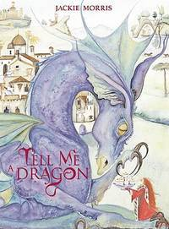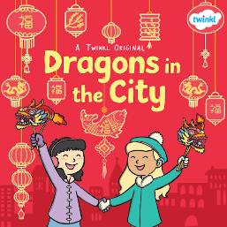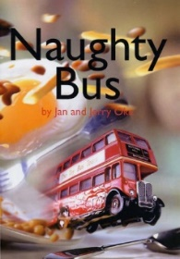 | 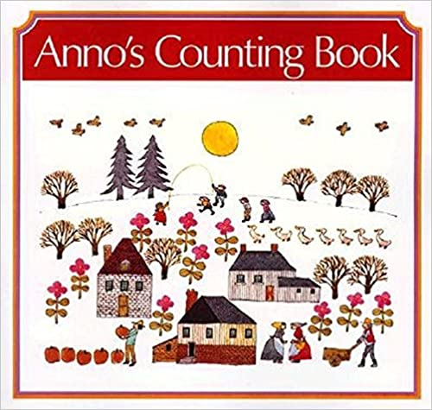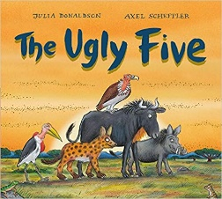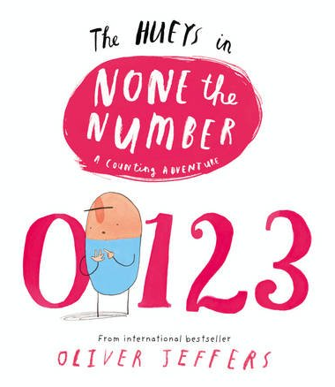 | 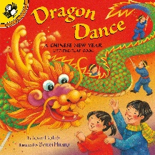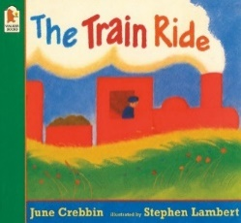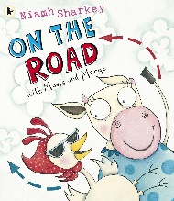
Specific Vocabulary | Blurb  Author  Illustrator  Letter name  Letter sound  Special friends (phonics) | Zero  Mass  Capacity  Greater  heavy, heavier, heaviest,  light, lighter, lightest  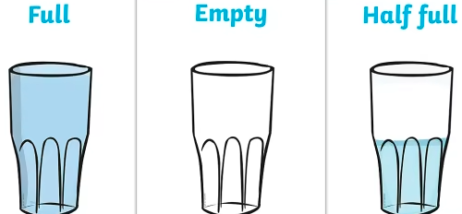 | Transport  Travel  Engine  Wheels  Road  Road signs  London  Tourist  Vehicles  China
Sticky Knowledge about… | I know the sounds:  ay, ee, igh, oo, ow  We live in Elton, Elton is in England  London is the capital city of England. | The heaviest side of a balance scale is lower.  bigger items are not always heavier than smaller items.  Zero means that no objects are present.  when comparing  numbers, one quantity can be more than, the same as or  fewer than another quantity.  All numbers are made up of smaller numbers. | A vehicle is a mode of transport to help a person travel from one place to another  Engines are used to power most vehicles today  Some vehicles can travel on roads but some can only travel in water or in the air  Vehicles can be used to help people do their jobs.  China is a very big country. It is a long way away.  The colour red is a lucky colour for the Chinese people.  Chinese people preform dragon and lion dances.

Term: spring 2 Topic: Spring into Spring Year Group: Reception
 | English | Maths | Wider Curriculum
 | The journey home | Building 9 and 10 | Spring into Spring
Book links | 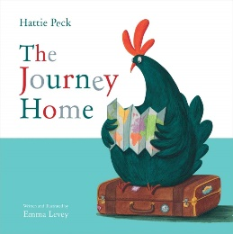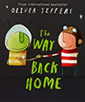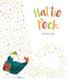 | 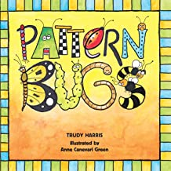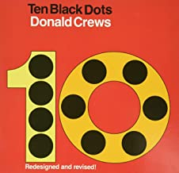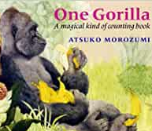 | 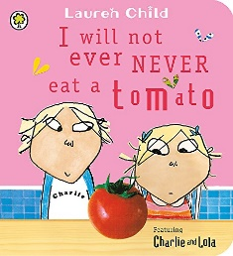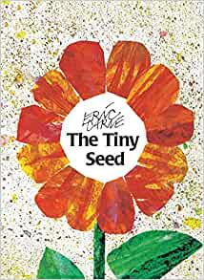
Specific Vocabulary | Rhyme  Segment  Blend  Author  Illustrator  Capital letter  Full stop  Finger space | Representing  sorting  Order numerals  Composition  Counting back  Comparing  matching  Pattern | bird  fish  insect  reptile  mammal  shell  fragile  speckled
Sticky Knowledge about… | A sentence needs:  Capital letter to start  Finger space between words  Full stop at the end.  I know the sounds:  ay, ee, igh, oo, ow, oo, ar  I know the tricky words:  I, to, the, go, no, said, my, you | A ten frame is full when there are 10 items in it.  I know where each number sits in relation to other on a numbers on a number line.  I know number bonds to 5  Identify and describe:  Cylinder  Cube  Sphere | I know that some animals come out of an egg.  When they come out of the egg they are young.  Over time they grow bigger.  I know that families can look different and have their own customs and routines  Spring is when lambs are born  We celibate Easter.  In spring it starts to get warmer.  Plants need sun, water and soil to grow.

