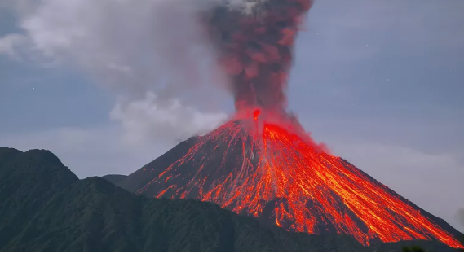 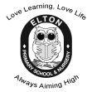

**Year 4 Learning Leaflet**

**Spring 2021**

Natural disasters

Love Learning, Love Life

Always Aiming High

Welcome back Year 4.

I hope you all enjoyed your Christmas holidays and had a well-deserved rest! I hope you are ready to learn as we step into our first spring term in year 4. We have lots of exciting lessons planned. There will be a big focus on our reading and times tables this half term to support you with the rest of your work.

**PE**

PE will be on Thursday and Friday. This term Danielle (our PE specialist) will be teaching on Fridays and Miss Preugschat will be teaching on Thursdays. You will need to have a labelled PE kit in school at all times, which can be taken home to be washed over the weekend or half termly.

**Homework, Spellings and Reading**

As we did last term, Learning Log homework and Maths will be given out on a Friday and returned on a Wednesday. Reading books need to be changed at least once a week and don’t forget to bring your Reading Journal and book in everyday, so that we can keep track of the books you are reading. You need to continue to learn your times tables at home as well as covering them in class. Finally, spellings will also be given out on a Friday and will be practised through the week.

**Miss Preugschat**

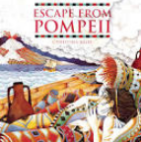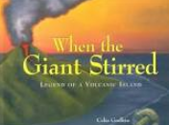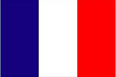

In **PE** we will be participating in activities gymnastics, football, hockey and outdoor adventurous activities. Throughout the year, we will also continue to have the opportunity to participate in class competition.

In **Music** we will have weekly sessions on a Tuesday afternoon. We will be following the Charanga theme which allows children to focus on each aspect of the musical curriculum.

In **R.E** we will be learning more about Christianity and how Jesus taught the people about God and values through parables.

In Maths we will be following the White Rose Maths scheme of work, which develops the children’s fluency with number and their mastery at applying these skills to problems and puzzles. We will continue our work on multiplication and division. We will then move onto measurement looking at area then towards the end of the term we will begin to look at fractions. We will also continue to build on our recall of times tables.

Our topic this term will focus on natural disasters including earthquakes and volcanoes.

In **English** we will by focusing our learning around the books called Escape from Pompeii and When the Giant Stirred. We will continue to learn how to incorporate fronted adverbials, conjunctions and rich vocabulary in our writing. Our writing outcomes this term are story writing and persuasive leaflets.

In **Computing** we will be learning about animation.

In **Science** this term, we will be focusing on States of Matter. We will compare and group materials together, according to whether they are solids, liquids or gases. We will observe that some materials change state when they are heated or cooled, and measure or research the temperature at which this happens in degrees Celsius (°C). We will identify the part played by evaporation and condensation in the water cycle and associate the rate of evaporation with temperature

In **French** we will continue to develop our skills in conversational French and learn about the culture.

This year, we will deliver Art and DT in blocks at the end of the half terms. In **Art** we will create sketches of volcanoes. In **DT** we will develop our skills in textiles by looking how to create exploded diagrams by building a volcano.

Our **Geography** this term will be taught through our topic of natural disasters. We will learn about the natural disasters that have happened all over the world, looking closely at the Bay of Naples in Italy and the famous volcano eruption. We will look at contrasts of regions in the UK with the Bay of Naples.